In this lesson we will be playing with the chroma keyer and green screen , blue screen

Black screen trying to remove background from your video and image so te get started we need some footage you might have our own green screen footage if you don’t have then you just grab some to play with at Pixabay

SO pixabay offers free stock photography and videos it

It also has some affiliate links to paid(who knows)

We search for video here and we search green screen

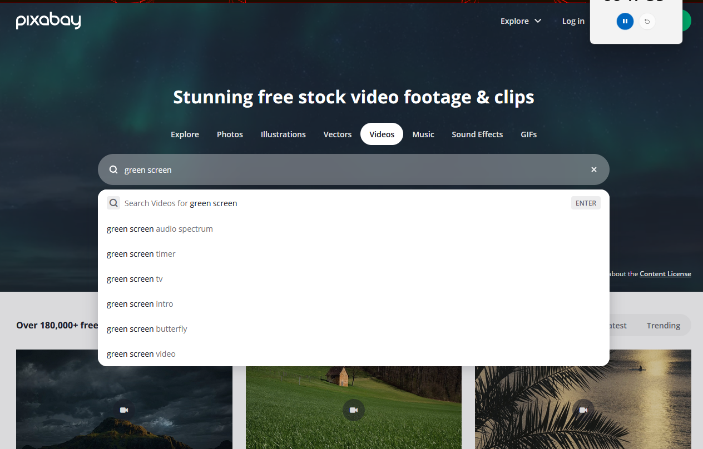

So now we see all these videos that we can download for free and use in our game screen project

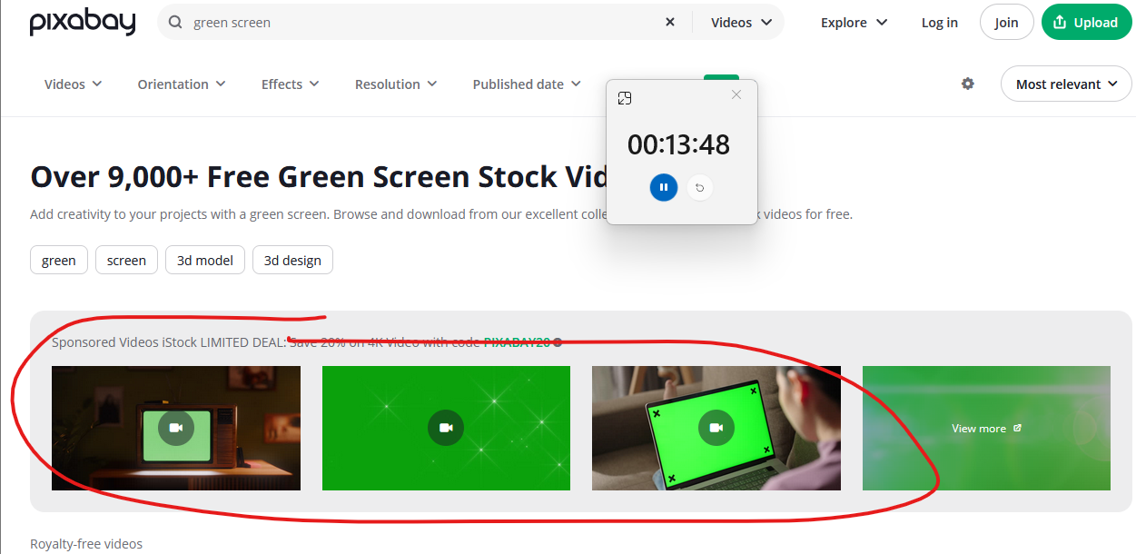

Some are sponsored (as marked above)so they are paid

All other are free choose one which you like and download it

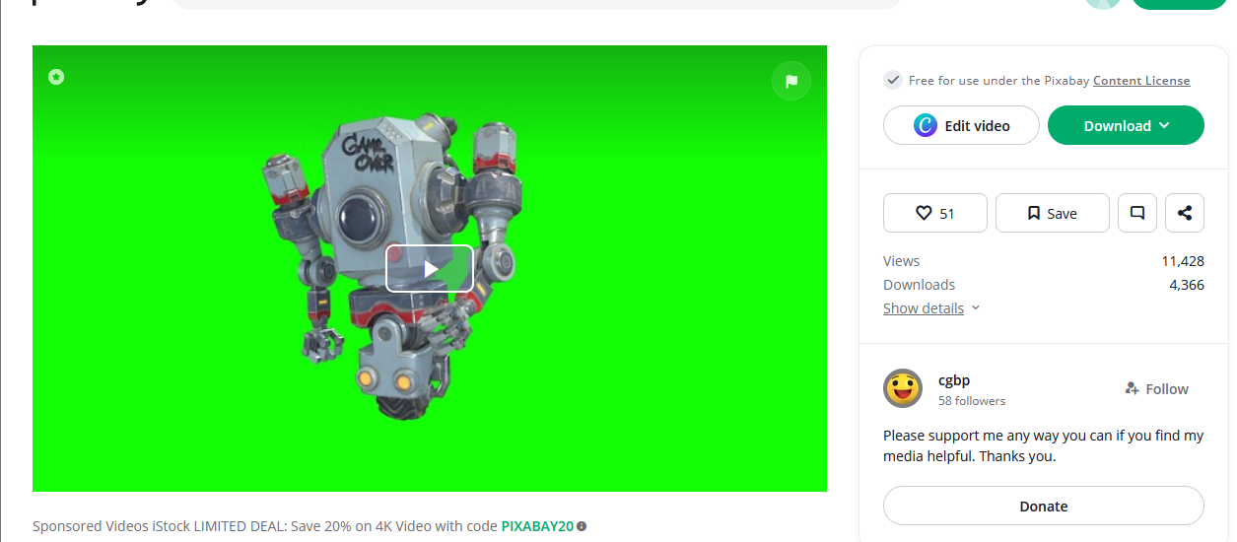

Now we read it in our natron so to do that we go the image nodes

And then read and then we find out video and then click on open button

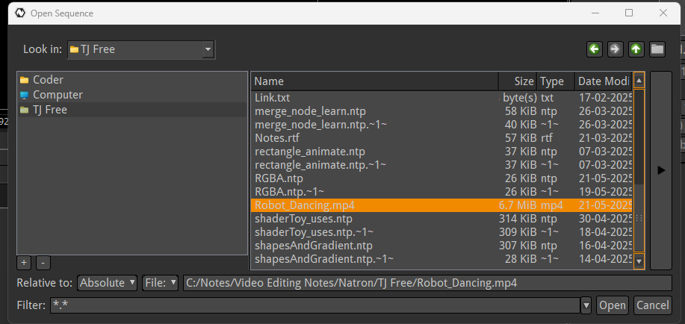

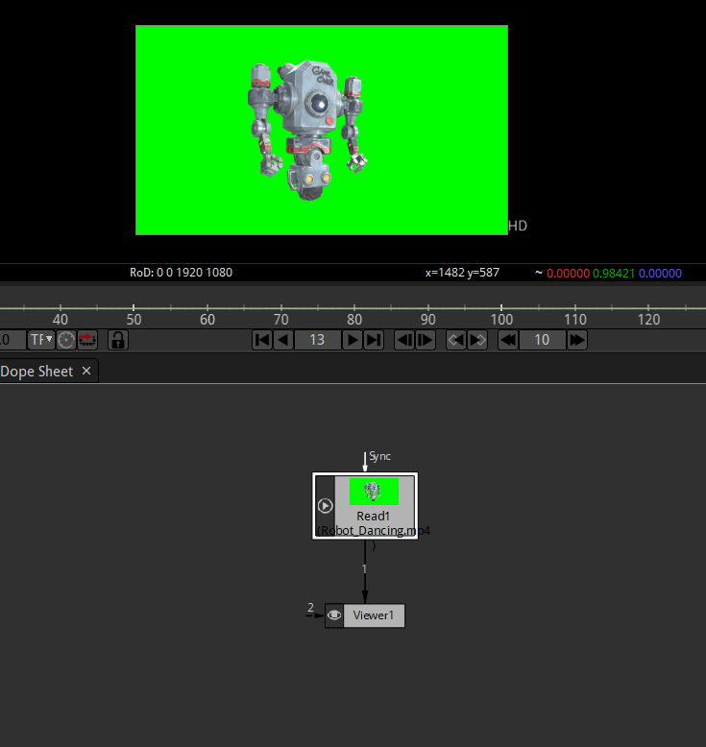

Now we connect the read node to the viewer node

Now It will look like above

Now we want to remove this green background

To do that we need to go to our keyer nodes as shown below

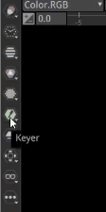

2:05